

Opting Out Course Sections

Visit the GatorEvals central portal via - https://my-ufl.bluera.com

A few things to note before opting out courses

All courses taught by a faculty member, adjunct, and graduate assistant must be evaluated by students using GatorEvals.

DIG users could opt-out courses for the following reasons:
- Courses involving individual instruction such as independent study, internship, practicums, thesis and dissertation supervision, etc. Typically, these courses are not evaluated.
- Courses or class sections involving types of instruction that occur outside of traditional classroom and/or laboratory settings for which the assessment questions would not be appropriate; and
- Class sections for which the number of possible respondents to the instrument is so small as to make the results of limited statistical usefulness, such as any course where the number enrolled is less than 5.

You may read more about GatorEvals Policies and Procedures.

To opt-out for a single course section, click on the current term “Main DIG Project...” under “My Active Tasks”

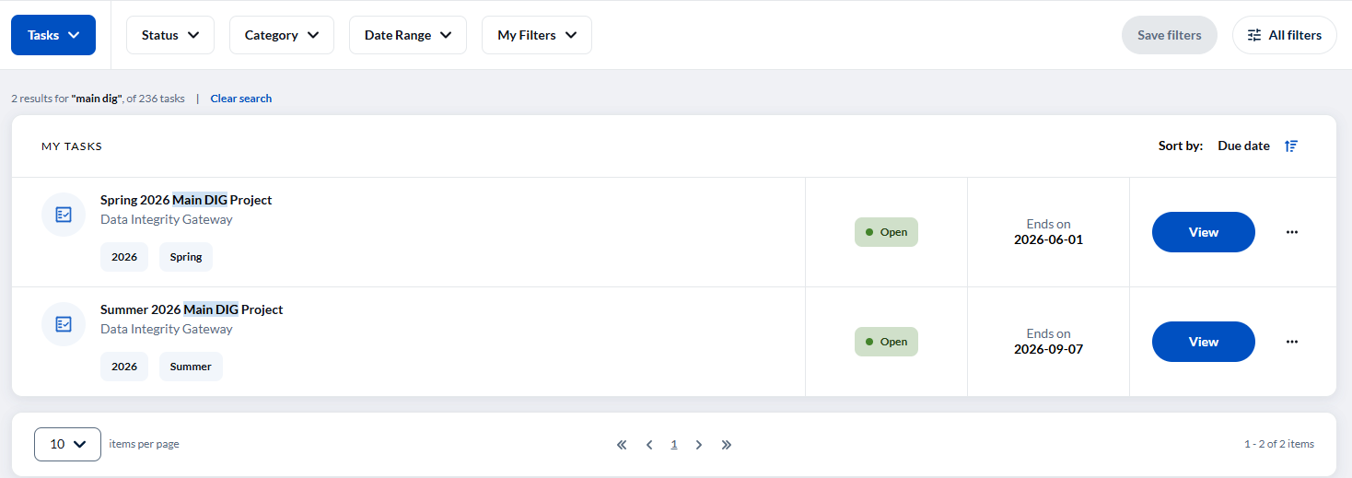

OR you can type in “Review and publish” in the upper search bar of the page.

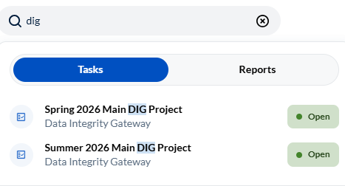

On the new page, locate the course or section.

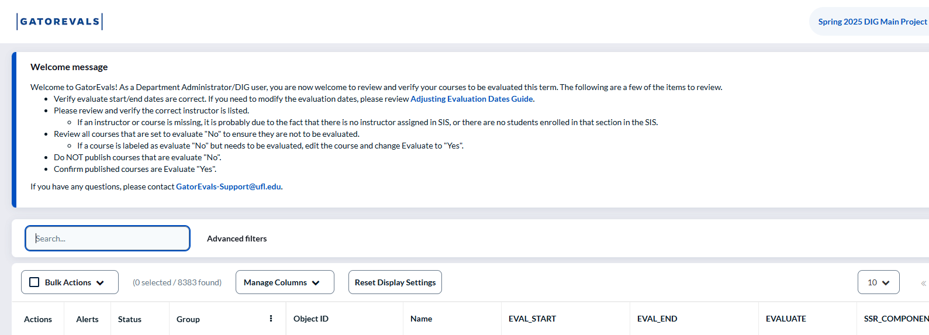

Click on the Evaluate field row for the corresponding course or section.

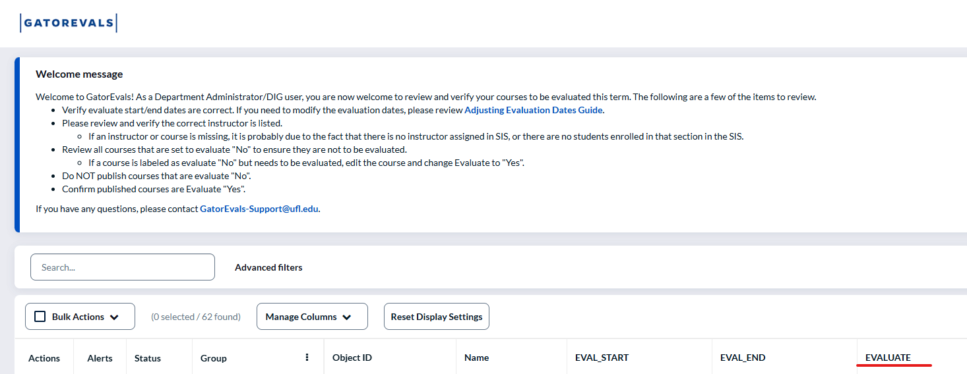

Change the value to “No” for that particular course section.

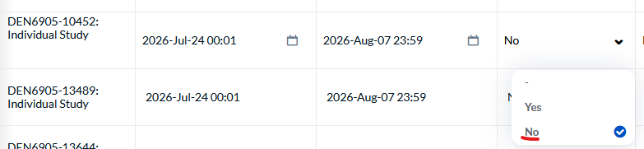

Save your changes.

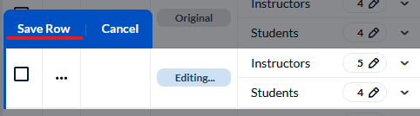

To opt-out multiple course sections, select each and click on “Bulk Actions”

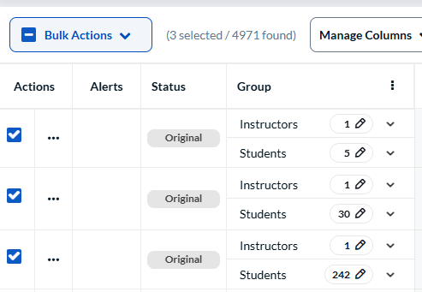

Click on “Edit courses fields”

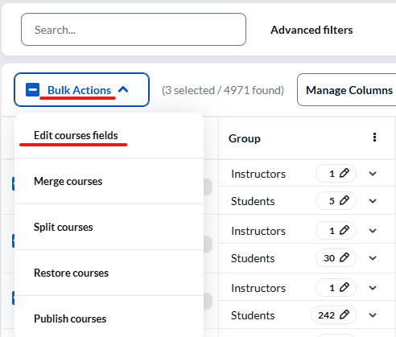

Under ‘Field’ select the EVALUATE field. Set the New Value to No. Select Apply.

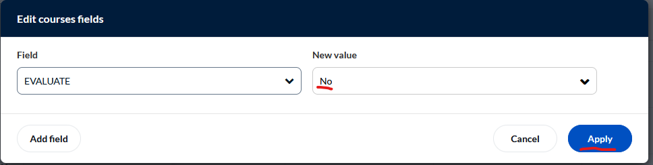

A confirmation screen will be shown. You will also have the strikethrough view to see the changes made. Validate that these are the correct records to update and then click “Yes, I’m Sure”.

