

GatorEvals DIG User Blue 9 Step by Step Guide
Contents
GatorEvals DIG User Blue 9 Step by Step Guide 1
Step 1: Logging In to GatorEvals 1
Step 2: Setting up Evaluations 2
Assigning Instructors 7
Step 3: Reviewing Courses to Evaluate 15
Request the proper SailPoint/ARS role 21
Monitoring Response Rates 21
More Information on Response Rates 23
Frequently Asked Questions 23

Step 1: Logging In to GatorEvals
The central portal of GatorEvals has been updated to the following link - https://my-ufl.bluera.com that includes a new user interface for all faculty, staff, and students. The Response Rate Monitor, GatorEvals Individual or Aggregate Dashboard, Bookmarks, and Response Rate/Opt-In Cards are on the left-hand side for easy access.
Reports and tasks can be saved as bookmarks. This may be particularly useful if there are certain reports referred to often.
- Login with your GatorLink username and password. We suggest adding the new link to your Bookmarks bar.
- The new user interface looks like this:
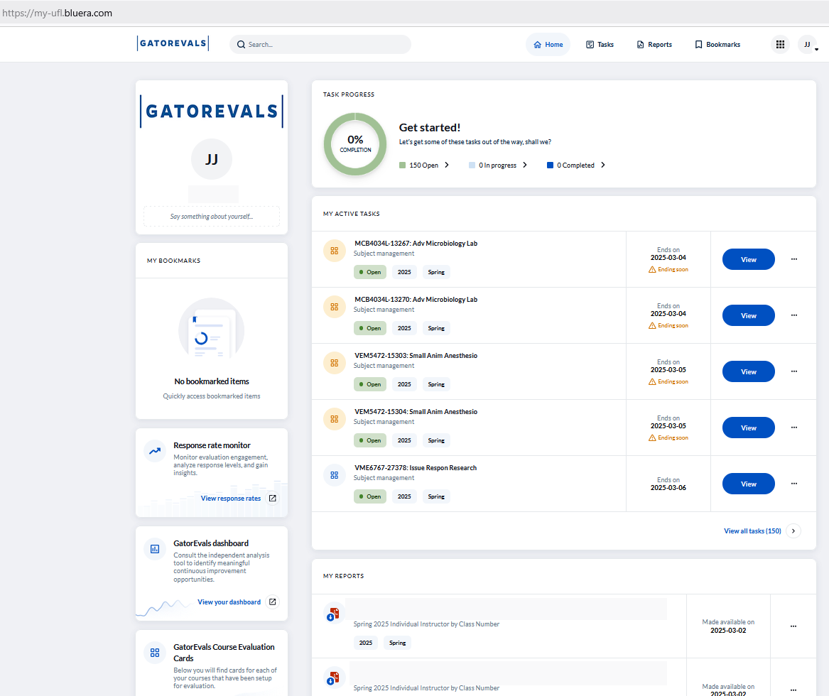

Step 2: Setting up Evaluations
      - In the “My Active Task” Section, select “Term Main DIG Project” the data assigned to you…”

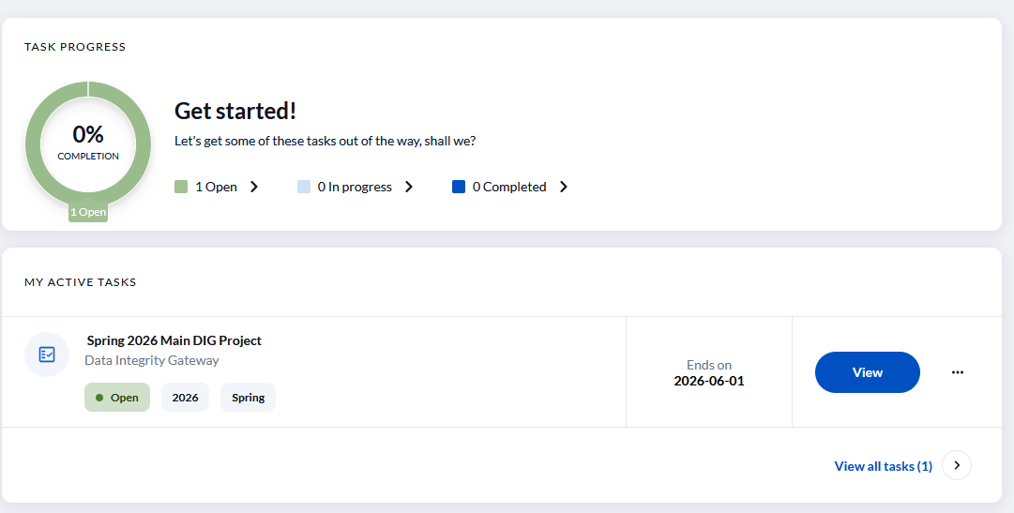
OR
If you only see View Response Rates in your lists of tasks, you can type in “Main DIG Project in the search bar at the top of the page. Or you can click, “View All Tasks” at the bottom of the “My Active Task” section.

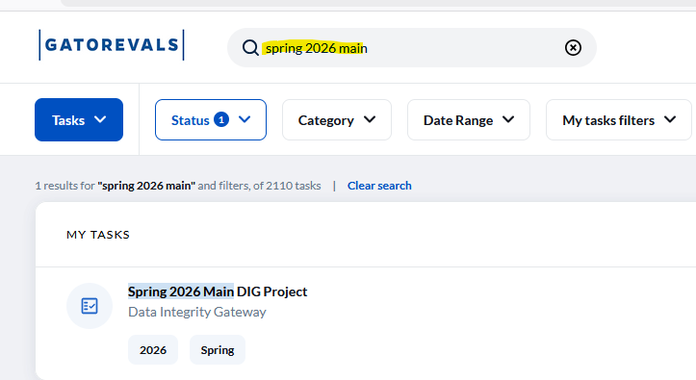
      - Once you’ve selected “Term Main DIG Project…”, it will take you to a screen like the one below. The spreadsheet view is now editable in-line.

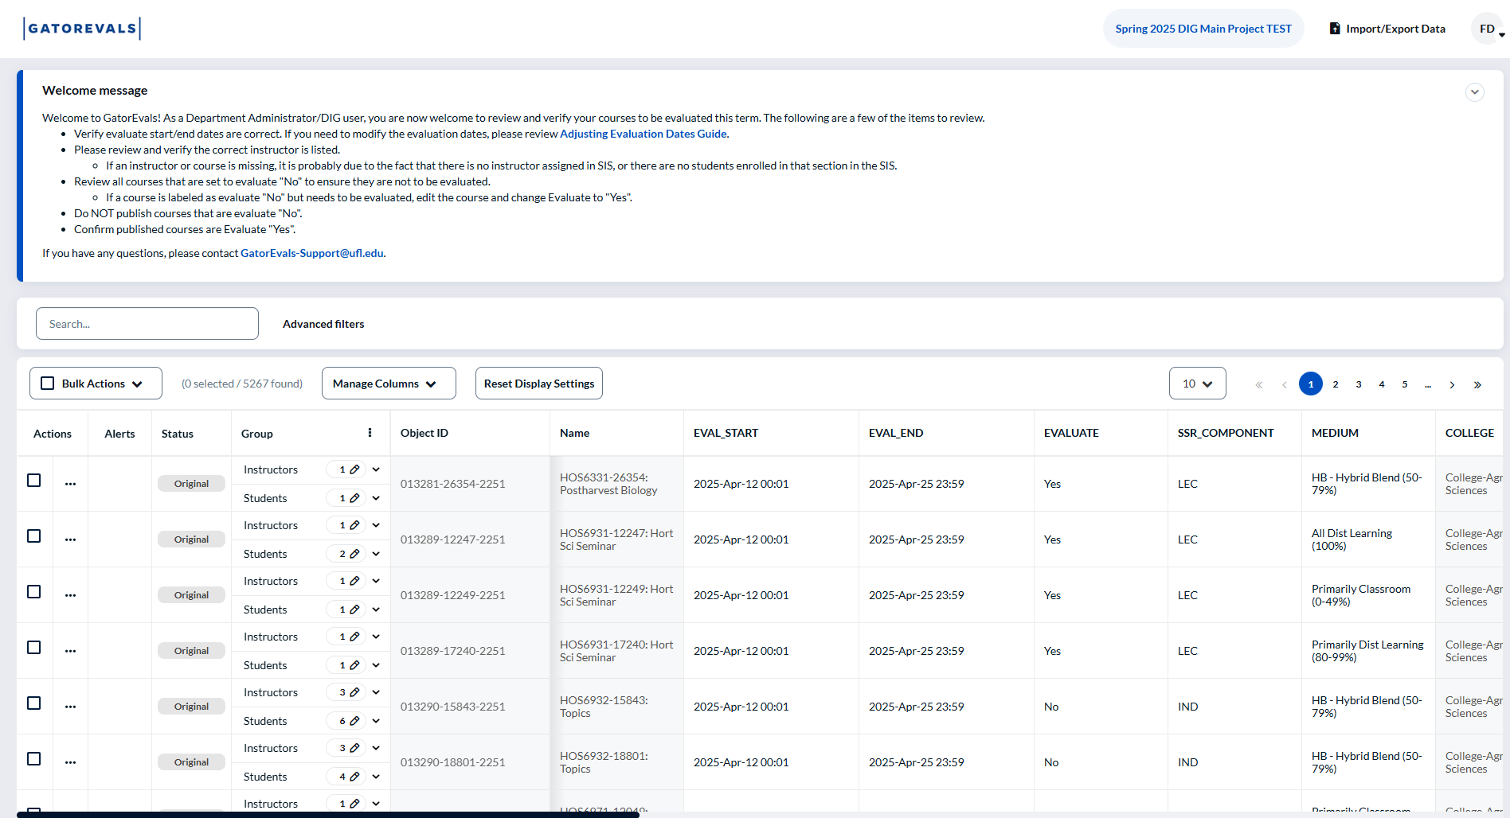

        - Select ‘Manage Columns’ to add or remove additional columns from the working view:
          - Any item with a greyed out check box cannot be removed from the active view as it is a field with data rules (like a list or date restrictions), but there are additional columns that may be useful for providing context or sorting.
  - These columns can also be reordered by clicking the 6-dot icon and dragging them up or down, so more useful columns can be moved to beside relevant ones (like showing course name beside section number).
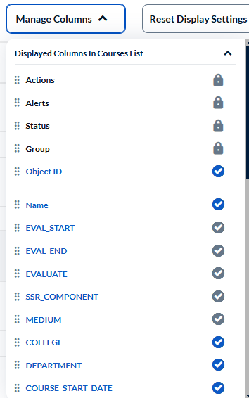

    - NOTE: You can rearrange and add/remove columns (note only some columns can be removed from the view) and courses can be published in line.
  - Additionally, editing in-line is possible. You may find the course that needs a field updated and click in the row in an editable field, enter the updated information, and click “Save Row” to save the changes.
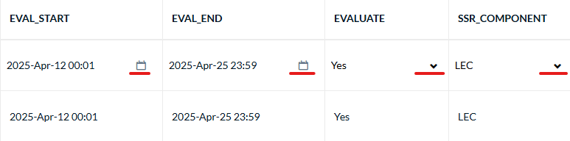
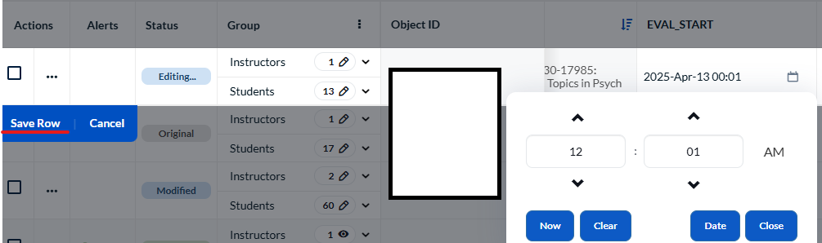

    - The “Actions” column shows the following options: Split, Restore, and Publish.

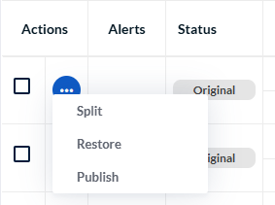

- The “Actions" column also shows the Merge option when you select two or more Class Numbers with low student enrollment taught by same instructor/course.
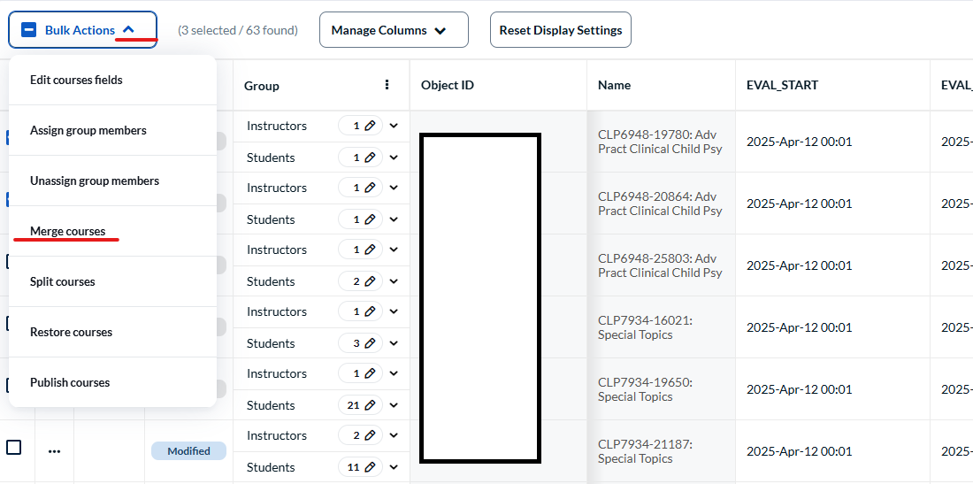

- The “Group” column shows the number and names of instructors and students. You can click on the dropdown next to the number and pencil icon to view the list of instructors and students.

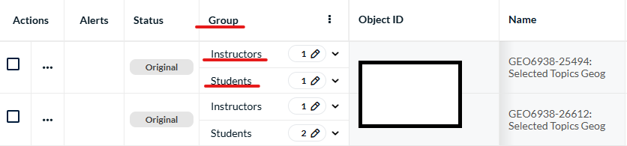

Assigning Instructors
      - DIG Admins are responsible for ensuring the correct instructors are listed for each course.
        - You can now review instructors at a glance by clicking the three dots in “Group”, then “Expand Instructor”

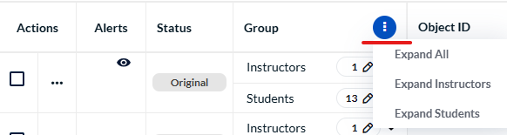

- Click the pencil icon beside Instructor and either delete an instructor or add a role.
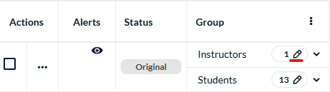
- If the instructor(s) listed is incorrect or you want to remove an instructor (after splitting), check the box in their row and then select the Remove button at the bottom left of the instructor screen.
- To add an instructor, click “Assign Instructor” in the upper right. Search for the correct / new instructor and click the blue Assign button at the bottom right to add them to the course.

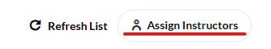

NOTE: To remove an instructor totally from the course, you would need to remove them from the Schedule of Courses first. It would take ~48 hours to sync in GatorEvals for them to be removed.
    - The “EVAL_START” and “EVAL_END” columns show the calendar icon to update or change the evaluation start/end dates. The time will always default to 00:01 for start date and 23:59 for end date.

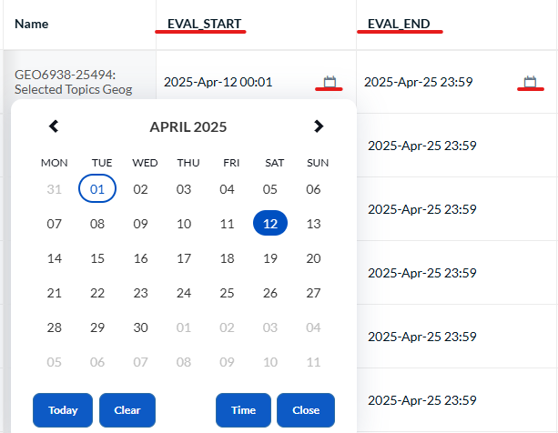

    - NOTE: Ensure you click “Save Row” to save the changes.
- You may also do bulk editing of the eval start and end dates. Find the courses that need dates edited and check the boxes beside those courses. In the upper right corner, click “Edit course fields”. For Field select one of: EVAL_START or EVAL_END. Or for both Eval_Start and Eval_End dates using the “Add field” button after the first one has been adjusted.
- Click the calendar icon on the right to find the correct date. Then click the blue “Apply” button.
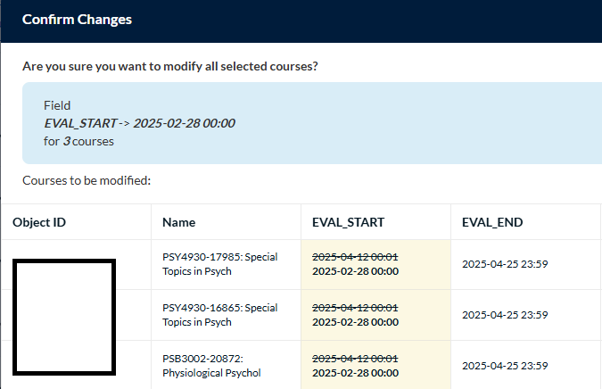
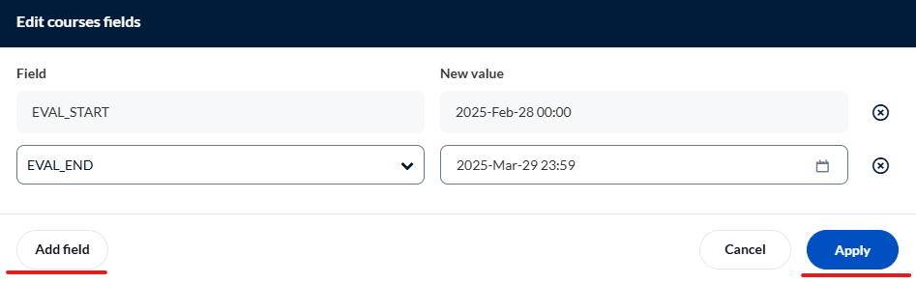
- The next screen will show which courses were selected to confirm changes are correct. Click “Yes, I’m Sure” to proceed.
- The “EVALUATE” column shows whether the course needs to be evaluated or not.

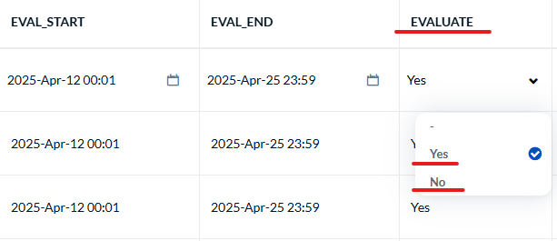

- Find the course that will not have an evaluation set up, click in the row under “EVALUATE” column. In the drop down, change it to “No”. Ensure you click “Save Row” to save the changes.
  - The “SSR_COMPONENT” indicates the type of questions students will receive for evaluations. Typically, by policy, courses with the SUT, GRD, DIS, PER, THE, and OTH are set to Evaluate “NO”, as these are considered courses with a one to one relationship between student and instructor. If they are set to “Yes”, please review to ensure they need to be setup for evaluation. If not, you can change the “Evaluate” to “No” in the dropdown and select Save.
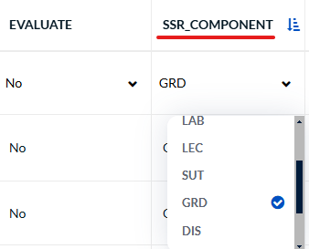

  - Additionally, courses with the LAB designation are considered Lab courses and will receive the Supplemental Lab Questions.
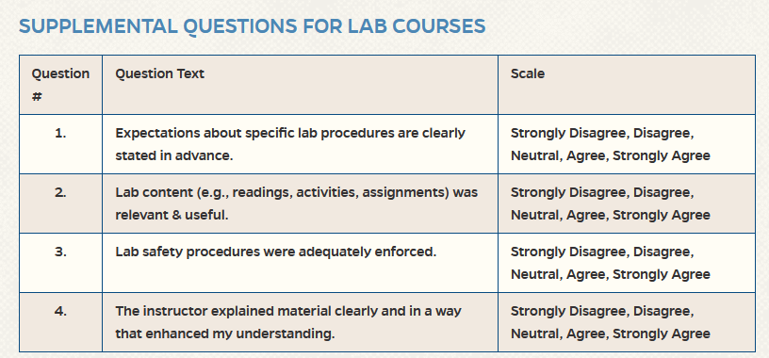
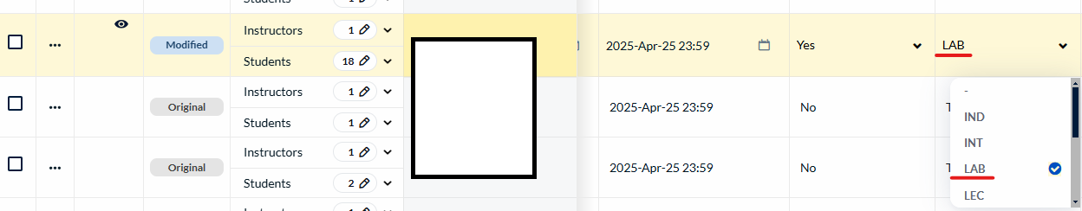

  - The “MEDIUM” column indicates what type of questions students will receive based on the mode of instruction. For courses with the designation “Primary Dist Learning” or “All Dist Learning”, they will receive the Supplemental Questions for Online Courses.



NOTE: If you merge any section that have different “Medium” designations, you might see an error in the Action column. You will need to go to this column and select only one option from the “Medium” designation. Our suggestion is that you select the Medium that most closely aligns with the higher enrollment section. So, if most students are in the Primary Classroom Medium, select that as the option.

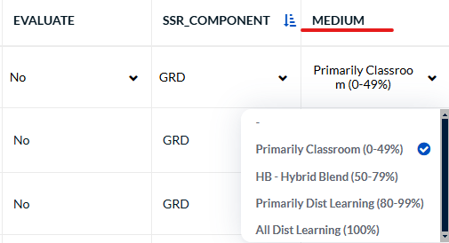

  - To the far right is the CLASS_ATTR showing the different sections by which students are evaluated.

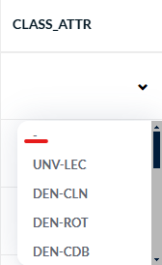

  - The dash option provides students with the standard Instructor and Course Evaluation Questions.
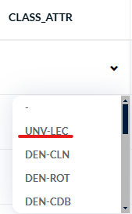

    - Choose the UNV-LEC option notably when splitting for the TAs, GAs, etc. The link to learn how to split sections is provided later below.

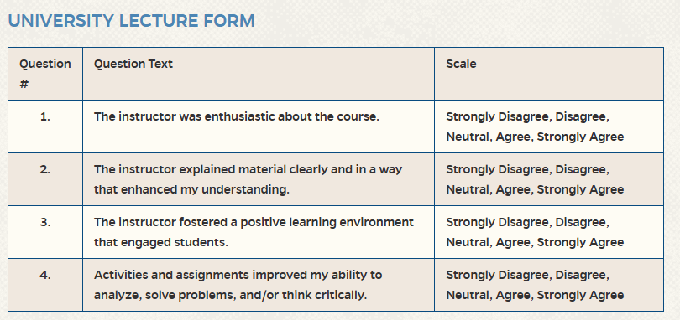

Step 3: Reviewing Courses to Evaluate
- Review the number of courses to evaluate.
  - Check the number of courses to ensure all courses under your purview are listed in GatorEvals. If there are courses/sections missing, there are usually a few reasons:
    - There is/are no instructor(s) assigned to the course/section in SIS. Check the UF Schedule of Courses via https://one.uf.edu/soc/ to see if they are properly listed. If not, talk to the course scheduler to make that change. Typically takes 48 hours for the instructor to appear in GatorEvals.
    - There is/are no student(s) enrolled in the course/section in SIS.
    - The course is considered a one-to-one student to faculty relationship such as Graduate dissertation or Thesis. These courses can be excluded from the SIS nightly data upload into GatorEvals.
  - NOTE: SIS is Registrar data that we pull course/section/instructor information from. This is NOT the same as Effort/AAR reporting. SIS data is considered canonical, so please make updates/changes to SIS first before contacting GatorEvals-Support.
- Review list of courses/sections where “Evaluate” is set to “No” to check if any needs to be changed to Evaluate “Yes”. If any of those courses/sections need to be evaluated, change the “Evaluate” field to “Yes” and then select “Save Row”.
  - REMINDER: By policy, Independent Study, Internships, Practicums, and other courses that are considered a one-to-one relationship between instructor and student are typically not evaluated. Additionally, courses with fewer than 5 students are typically not set up for evaluation.

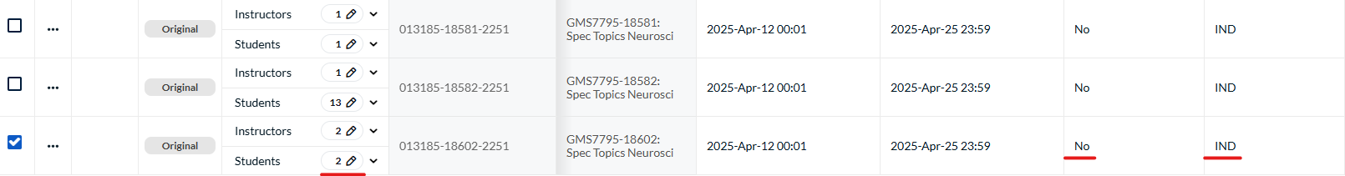

- You can also make use of the “Advanced filters” to do a quick search.
Then select “Add”

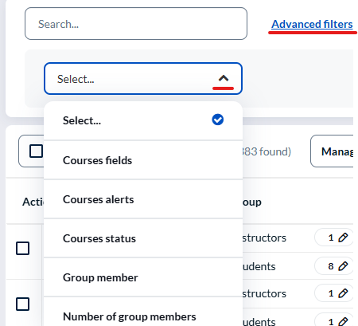

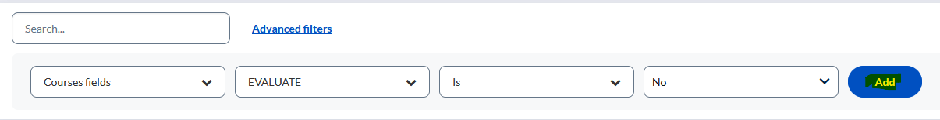
- You can also filter by choosing “Evaluate” is “No” using the “Advanced filters”.
- You can do bulk editing by checking the boxes beside any courses that will have evaluation set to “No”. In the upper right corner, click Edit courses fields.

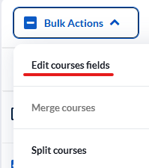

- For “Field”, select “Evaluate”, for “New value” select “No”, click “Add Field”. Click the blue “Apply” button. The next screen will show which courses were selected to confirm changes are correct. Click Yes to proceed.

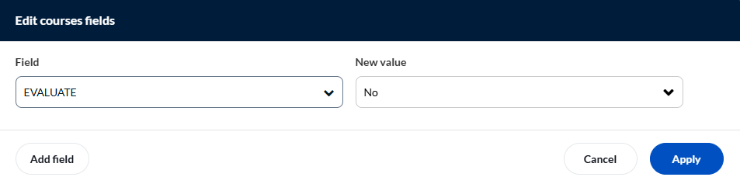

- Once you have reviewed the courses/sections using the “Advanced filters” option and made any other changes that were needed, click on the “x” to remove the filters.
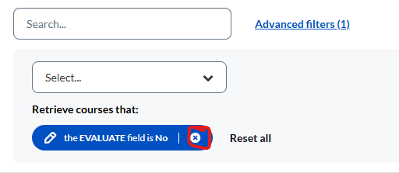

- Default is yes for all courses.If any of the courses that are set to Yes when you do the filter don’t need to be evaluated, please make sure that you change them to No and save.
- You can do this individually. Find the course that will not have an evaluation set up, click in the row under the “Evaluate” column, in the drop down change it to “No” and save the changes.
- You can do bulk editing. Check the boxes beside any courses that will have evaluation set to “No”. In the upper right corner, click “Edit course fields”.

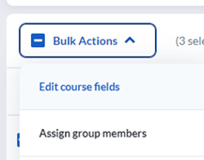
- For “Field”, select “Evaluate”, for “New value” select “No”, click “Add Field”. Click the blue “Apply” button. The next screen will show which courses were selected to confirm changes are correct. Click Yes to proceed.

- Review each course/section that are set to “Evaluate” is “Yes”.
- A few items to look review/confirm:
- Eval_Start – make sure the start date is correct. You may need to change this for any modular courses being offered.
- Eval_End - make sure the end date is correct. You may need to change this for any modular courses being offered.
- Evaluate – Yes or No, be sure the correct option is selected for each section.
- SSR_Component – LEC is the most common SSR component and indicates that students in this course will receive the standard university core questions known as the Instructor and Course Evaluation Questions.
- LAB – students will receive the university core questions + Supplemental Lab Questions.
- IND – independent study – these courses are generally set to evaluate “No”.
- INT– internship – these courses are generally set to evaluate “No”.

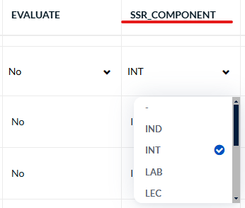

  - Medium – students in distance/online courses that are 80% or more online (Primary Distance or All Distance) will receive the university core questions + Supplemental Questions for Online Courses.
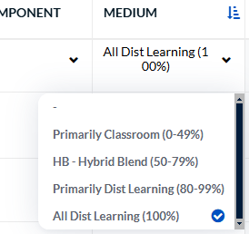
  - NOTE: Confirm that all instructors and TA/GAs are properly assigned. If an instructor is missing, confirm that SIS data is correct. All instructor(s), whether primary instructor or GA/TA need to be given the Primary or Secondary designation in the dropdown in course scheduling.
- Publish courses set to Evaluate “Yes”. Select only the course section that needs to be evaluated. Click the 3-dot icon in the row for the course section ready for publishing in the “Actions” column.
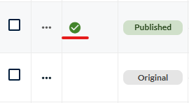
  - NOTE: Bulk publishing is still available for two or more courses.
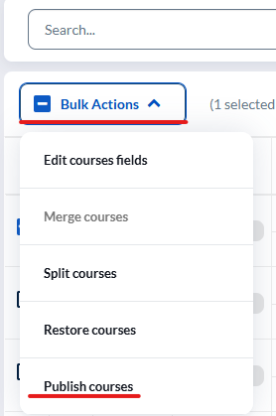

  - Click the checkbox beside each course that is ready for publishing.
  - Once you have confirmed all the information for each course, you can click on “Bulk Actions” and select “Publish Courses”.
  - The pop up will indicate which courses will have their status changed to published. Click confirm to continue.
  - Published courses will have a green check icon.
- NOTE:
- Please note, once you click “Publish Courses”, you will NOT be able to make any edits to that course. So please publish carefully.
- Contact us immediately at GatorEvals-Support@ufl.edu if you need to make changes to the published course.
- For more information, check the DIG User Guides which can be found on our website https://gatorevals.aa.ufl.edu/administrators/dig-user-guides/ on:
    - How to Adjust Evaluation Dates
    - Splitting Course Sections
    - Merging Course Sections: You don’t publish a course that has one student, but you can merge it with a high enrollment course taught by the same instructor. In addition, to view merged courses, you need export rate monitor rates.
        - NOTE: You can merge courses with fewer than 5 students with another low enrollment course taught by same instructor and same course. For example, MAN7935-12345 and MAN7935-67891 taught by John Smith can be merged. But an incorrect merge would be MAN7935 and MAR6635 taught by John Smith. So, if the course names do NOT match, even with the same instructor, they should NOT be merged.

Request the proper SailPoint/ARS role
In case you do not see the response rates monitor, please request either or both roles from your Department Security Administrator (DSA).
- UF_COURSE_EVAL_COORDINATOR
- UF_COURSE_EVAL_DPT_REPORT_VIEW

Monitoring Response Rates
Being able to watch the response rates for courses once the evaluation period opens can help DIG Admins and Instructors identify if there are courses that need some extra attention toward getting course feedback completed or highlight courses with excellent response rates that may be able to share their strategies for success with fellow instructors.
The response rate monitor provides some information on how students responded such as timing, browsers used, channels of access etc. During evaluation period, click on the response rate monitor to gain insights on the rates of students' engagement in completing the evaluation for their courses.

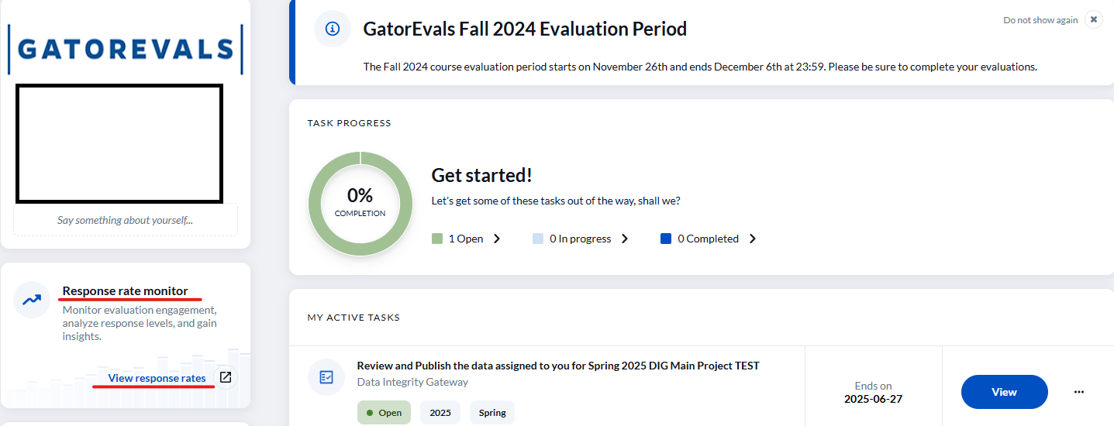
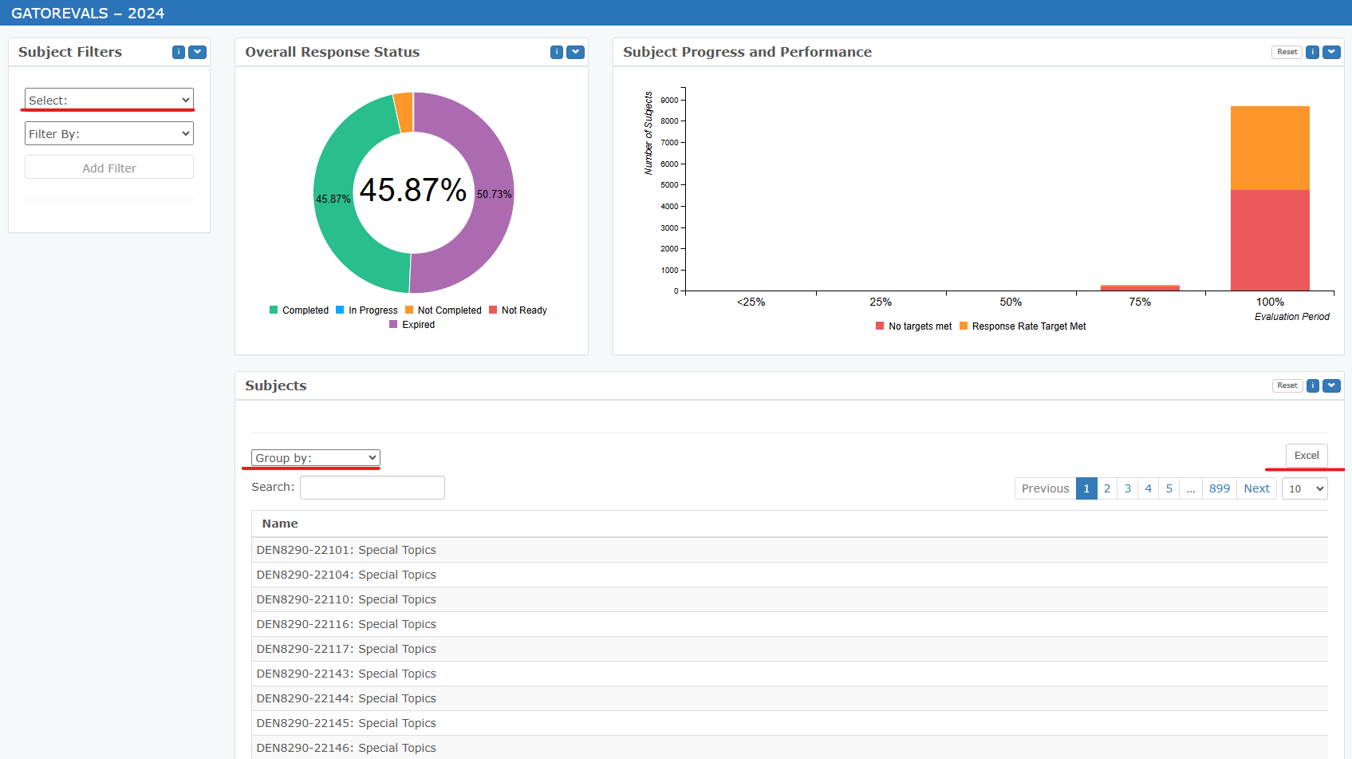
You can use the “Select” option under the “Subject Filters” at the top right corner of the Response Rate page or the “Group by” drop-down menu in the “Subjects” section to filter desired demographics.
You can also click on the “Excel” option located far right of the “Group by” option to download the Response Rates in a spreadsheet which can be sorted from low to high. The spreadsheet can be presented to your faculty, Department Chair or Dean.

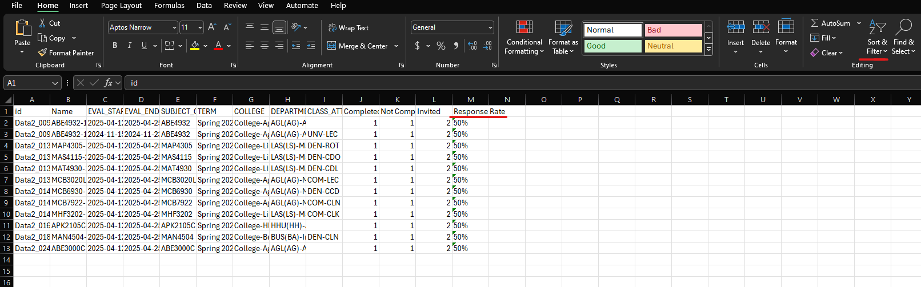

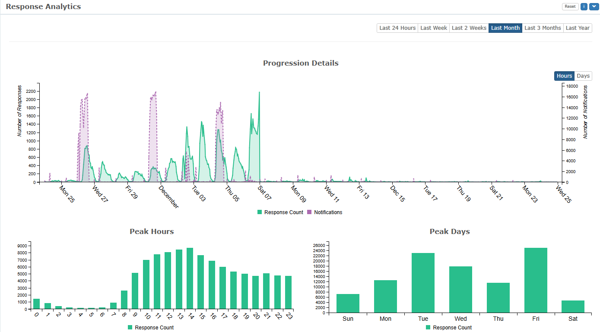

More Information on Response Rates
- Faculty can also monitor live response rates via - https://ufl.bluera.com/ufl/ or https://my-ufl.bluera.com
- If faculty or their students have any questions or are having trouble accessing their evaluations, please reach out to the GatorEvals Support team via gatorevals-support@ufl.edu.
- Students can complete evaluations through email, in their Canvas course menu under GatorEvals, or via the central portal - https://ufl.bluera.com/ufl/ or https://my-ufl.bluera.com
- Department administrators and deans can download the Response Rate Export Report by department and college using the “Excel” button. You can then sort it by Response Rate low to high. They can view the report and the Response Rate Monitor in the central portal https://ufl.bluera.com/ufl/ or https://my-ufl.bluera.com

Frequently Asked Questions
      - During evaluation period, I can’t see the course listing anymore, only the response rates for all my courses. How can I find the course that I want to change Evaluate from No to Yes?
        - Answer: Please type in Term DIG Project" in the search bar at the top of the page or check “My Active Tasks” section and you will be able to view the course.

      - How do I know when to merge courses?
        - Answer: We only want to merge sections with low enrollment to reach at least 5 students. So, we typically merge sections having 1-4 students with another section of 1-4 students. Or in some cases, a section with 1-4 students with a larger section of 5+. But we don’t want to merge multiple sections where there are 10+ students.
        - In addition, the merged sections won’t show up in the Response Rate monitor. You need to have access to the Response Rate export report to view them.
        - Furthermore, when courses/sections are merged, students need to complete the evaluations via the central portal - https://my-ufl.bluera.com/
        - Can I publish a course set to Evaluate No?
          - Answer: We don't want to publish courses set to Evaluate 'No". You can leave them unpublished.
        - Can you still publish a course when the evaluation period is open or has begun?
          - Answer: Yes, it is possible
        - When a program runs on an alternate calendar and eval dates are customized, what happens to merged courses?
          - Answer: It’s important to remember for merged courses, it often won’t show up in Canvas as it created a new merged ID that might not link to Canvas. Students can always fill out the evaluations via the central portal - https://my-ufl.bluera.com/ . If they have issues, please have the instructor let them know to reach out to our GatorEvals Support email so we can address.
      - How do I remove instructors from the GatorEvals system?
- The instructor would need to be removed from the Schedule of Courses first. It would take ~48 hours to sync in GatorEvals for them to be removed.

